The Ethics of Biotechnology
Group Discussion Student Sheet

Background:
Ethics are the rules or standards that govern the way people behave and their decisions on the ‘right thing’ to do. It asks basic questions about what is right and wrong, how we should act towards others and what we should do in specific situations. One common feature of ethics is that different people with different values often disagree on the ‘right thing’ for individuals and society. There is no clear right or wrong position in ethics, as a person’s individual experience, culture, education, and overall view of the world often guides the way they make ethical choices. Ethical views can evolve and change over time as society’s values change.

For instance, someone with a strong environmental outlook might see the use of genetically modified (GM) crops as unnatural. But someone with a strong scientific-based view of the world might see the use of GM crops as a natural extension of traditional crop breeding technologies.

There are particular ethical positions that are commonly shared, such as the view that it is essential for all biotechnology products to be safe for humans and the environment.

When looking at ethical positions it is important to realize that the ‘right thing’ for one person may not be right for others and it can be very difficult to balance these conflicting views.

Biotechnology Discussion Questions:
1. Bioengineered crops or genetically modified (GM) foods are plants or animals whose genomes have been changed in some way. Perhaps this plant or animal’s own genes have been manipulated to make them “better” or a gene from another organism has been added for a targeted benefit (Bt corn to protect against rootworm). These changes can potentially increase the amount of food we produce per acre, reduce the amount of pesticides that are used, and make certain foods more healthy (golden rice).
However, there are a number of ethical concerns over genetically modified (GM) foods that have triggered governmental regulations and affected public support. Concerns range from the environment to risks to our food web to issues concerning disease, allergies and contamination to relative costs for farmers.

- Bt corn has a gene inserted from bacteria. The plant produces the bacterial protein, which kills the corn rootworm. Before Bt corn, farmers would spay pesticides to protect their crops. These pesticides would get into local water and would not last through the growing season, but Bt corn is protected throughout the growing season. The Bt corn product was tested for over 10 years in a lab and went through 2 years of government regulation review before put on the market. Bt corn has been growing in the United States since the mid 1990s and is still under government regulation.
Should Bt corn be sold across the world? YES or NO

- It is estimated that 85% of U.S. corn and 91% of soybeans are genetically modified. 70% of all processed food on supermarket shelves (soda, soups, crackers and condiments) contain a genetically engineered ingredient.
Do you believe every product sold with a GM ingredient should be labeled?
YES or NO

- The seeds for a genetically modified crop are produced by a biotechnology company and sold at a cost much higher than a non-genetically modified seed because these plants should outperform a normal plant. Farmers who buy the seeds must sign a contract promising not to save seeds meaning they must by new seeds every year.
A farmer, Mr. Bowman, who wanted to grow a crop later in the growing season did not want to spend the money to buy expensive GM seeds because winter might come early and kill all his plants. Instead he bought seeds from a grain elevator that had a mix of seeds harvested from surrounding farms. He hoped many of these seeds would be GM. Grain elevator seeds are normally sold for animal feed. He planted the seeds, and many plants seemed to be GM based on their traits. He saved the seeds from this planting for future plantings. Do you believe what Mr. Bowman did was ethical? YES or NO

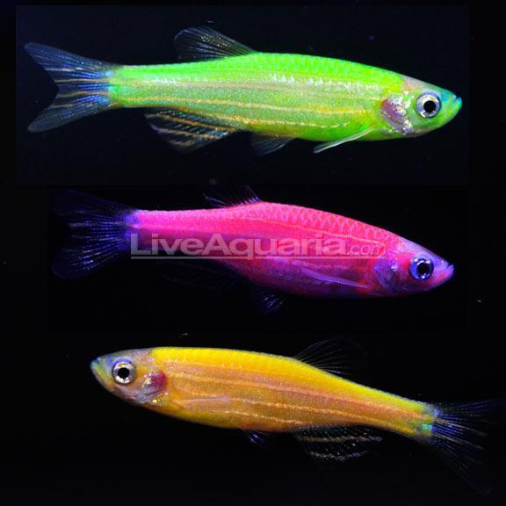
- The Food and Drug Administration (FDA) is currently reviewing and regulating a genetically engineered salmon, the AquAdvantage salmon that grows twice as fast as wild Atlantic salmon. This fish would be sold for people to eat. However, a new genetically engineered pet fish called the Glofish is not regulated. Do you think the U.S. Government should regulate all genetically modified organisms? YES or NO

2. Researchers have injected human genes into the fertilized eggs of domestic animals, for example pigs. One reason is for making such a pig is to make drugs in the milk of the pig. Another reason is to make internal organs adapted to humans. These are called animal bioreactors.

- Hemophilia is a disease where people cannot stop bleeding. Do you AGREE or DISAGREE that it is acceptable to make a genetically modified pig that would produce medicine for a person with hemophilia if the pig did not have to die?

- Heart transplants occur infrequently because donor human hearts are very rare. Is it ACCEPTABLE or NOT ACCEPTABLE to genetically modify pigs for heart transplants in humans?

